**Chatbots in the Realm of E-recuritment: Obstacles and Prospective Paths**



Name: Saad Ullah Anjum

Supervisor: Liam Doyle

ID: W20104784

Date Submitted: 03-01-2024

**TABEL OF CONTENTS**

**1- Introduction:** …………………………………………………………………………….. 3

1.1 Research Objective ………………………………………………………………..….. 3

1.2 Research Questions……………………………………………………………...……. 3

1.3 Research Methodology………………………………………………………………..4

**2- Literature Review**…………………………………………………………………….......4

2.1 Definition of Chatbots and how it works……………………………………………....4

2.2 Advantages and Disadvantages of using Chatbots ……………………………………5

**3- Recommendations to enhance online recruitment methods and procedures** ……..…7

**4- References**………………………………………………………………………………...8

**1- Introduction**  
  
Human Resource Management (HRM) is a critical element of modern organizations, essential for optimizing their most valuable asset, human capital. Central to HRM is personnel management, which handles the administrative aspects of staffing and employee relations, with recruitment being a vital component. Recruitment is the process of sourcing, interviewing, and onboarding qualified candidates. (Ahammad, 2017)

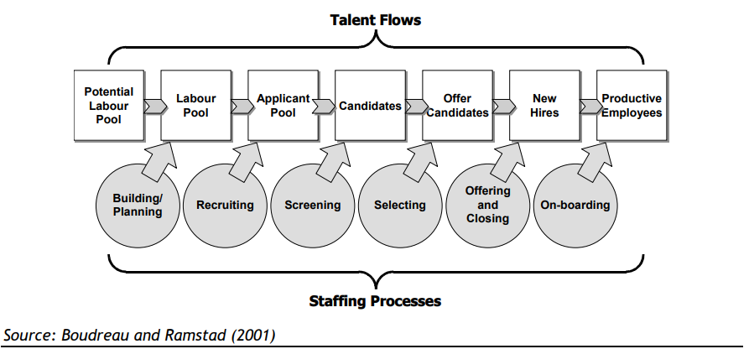

However, the advent of the Internet has revolutionized traditional recruitment methods. Over the past decade, online recruitment has gained prominence, transforming how organizations approach hiring. This trend is expected to continue expanding. Modern technology trends like artificial intelligence, advanced machine learning, and natural language processing have brought chatbots into everyday use. Chatbots, the talking or texting AI, help businesses by making online conversations easier. (Salama, 2021) This research will dig down into the usage of chatbots, explaining their benefits and obstacles encountered.

**1.1 Research Objectives:**

The primary objective of this research is to investigate the utilization of chatbots in the recruitment process, highlighting their beneficial impact on both recruiters and job applicants.

## **1.2 Research Questions:**

This dissertation will explore the following research questions

1. What strategies yield optimal results in leveraging chatbots in the field of e recruitment?
2. What are the obstacles in the way of using chatbots?
3. In what way can these challenges be effectively addressed and overcome?

**1.3 Methodology:**

This study solely relies on a comprehensive review of existing literature, aiming to gain insights into artificial intelligence chatbots and their role within the recruitment process. The research methodology involved sourcing secondary data from various scholarly sources such as journals, websites, and reports to construct a thorough understanding. Furthermore, library databases like Scopus, ProQuest, EBSCO, Science Direct, Emerald, Elsevier, Taylor and Francis, Springer, and Wiley inderscience have been accessed for gaining the required knowledge. The research was conducted using keywords such as artificial intelligence, chatbots, recruitment, and recruitment process. Search engines like Google and Google Scholar were utilized to identify and retrieve relevant working papers, reports, blogs, and presentations, ensuring a comprehensive coverage of the available literature.

**2- Literature Review**

**2.1 Definition of Chatbots and how it works:**

The transformation sparked by the internet's introduction revolutionized how companies seek candidates, leading to innovative tools like applicant tracking systems (ATS) and the integration of social media platforms such as LinkedIn and Twitter. These changes not only reshaped recruitment but also blurred the lines between personal and professional realms for job seekers, creating a new dynamic.

Amid this digital shift, chatbots emerged as intelligent assistants using AI to streamline HR functions like sourcing and scheduling, especially beneficial for handling large numbers of applicants in recruitment (Swapna, 2021). Their standout advantage lies in improving communication with candidates, easing the burden of managing numerous interactions.

Furthermore, AI recruiting technology doesn't stop at automation; it significantly influences the early hiring stages, freeing recruiters from time-consuming administrative tasks. Notably, AI algorithms are now employed during video interviews to delve into candidates' expressions, body language, and choice of words. This deeper analysis provides insights into their engagement levels, emotional intelligence, and nuanced traits like positivity and adaptability, marking a fundamental change in candidate evaluation methods.

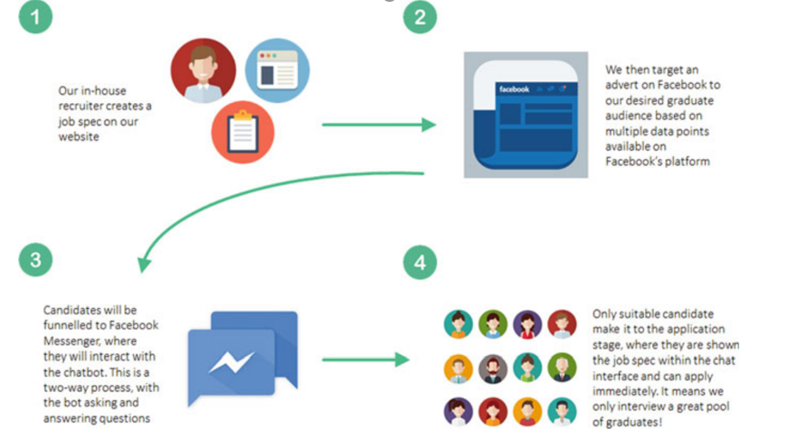

**Process of chatbot system for E-recruitment**

**2.2 Advantages and Disadvantages of using Chatbots:**

The utilization of chatbots offers numerous advantages, benefiting employers and employees globally. However, alongside these advantages, it is important to note that chatbots also have some disadvantages. Some of these pros and cons are discussed below  
  
**Chatbots Artificial Agency:** Chatbots, much like other AI tools, enhance their capability to evaluate and screen candidates through vital interactions with humans. Their capacity to independently make decisions and adapt based on the responses received from individuals involved is termed as their artificial agency, enabling them to improve their effectiveness and seamlessly integrate into the work environment . However, limited or inadequate data can significantly impact the quality of chatbots' performance, impeding their learning process and hindering optimization (Schildknecht, et al., 2018).  
  
**Reduction in cost and hiring time:** Typically, one of the most challenging tasks for those overseeing recruitment and selection processes is the extensive scrutiny of numerous resumes.Chatbots offer the potential to diminish the time and costs affiliated with recruitment and selection procedures (Balachandar & Kulkarni, 2018; They aid in evaluating and identifying more promising resumes concurrently during the initial stages of the process. Consequently, recruiters and managers can redirect their focus towards strategically significant matters. Furthermore, Geetha and Bhanu (2018) discuss the "Mapping of Talents" activity, where HR professionals and chatbots collaborate to identify potential talents in accordance with job vacancies, aiming to match talents with the right job roles. Black and Van Esch (2019) emphasize that reducing the time-to-hire not only signifies efficiency but also provides a strategic edge in attracting and recruiting valuable human capital, particularly in highly competitive industries prone to high turnover rates.  
  
**Chatbots Language:**Chatbots, distinctive AI assistants, engage prospective employees using 'Natural Human Language,' employing contextual language, expressions, and emotions to foster a positive candidate experience and simultaneously assess candidate qualities (Lokman & Zain, 2018). This approach allows chatbots to gauge sentiments like anger, frustration, and demotivation, thereby enhancing human engagement. However, as per Schildknecht et al. (2018), the intelligence associated with natural language poses a dual challenge: ambiguities in language, irony, informal expressions, or spelling errors can hinder chatbots' ability to comprehend responses accurately, impacting the entire interaction process.

**Cognitive biases:** Regarding human biases, chatbots circumvent the activation of these cognitive tendencies, fostering a more trustworthy and equitable approach compared to humans (Black & van Esch, 2020). Navaz and Gomes (2019, p.3) affirm that chatbots significantly aid recruiters through their quick responses and immediate availability. Furthermore, Black and van Esch (2020) outline several biases that commonly influence recruiters' judgments: Anchoring bias, where initial information holds undue influence without proper adjustment for subsequent data; Confirmation bias, seeking information that confirms past decisions while avoiding contradictory data; and Similarity bias, which inclines towards favoring individuals similar to oneself, regardless of potential positive or negative impacts.Chatbots operate based on information aligned with the ideal professional profiles suitable for available job positions, and the efficacy of AI relies heavily on the quality of the data it receives and utilizes. It is crucial to exercise caution regarding the input data—biased input data may lead to biased results, jeopardizing chatbots' transparency (Mohan, 2019).  
  
**Helpful in performing of repetitive task:** The digitalization trend involves automating aspects of cognitive work that are susceptible to automation . This includes instructing machines on how to execute tasks, with AI innovations being integrated to support and enhance traditional processes. Chatbots, as a groundbreaking AI tool, offer HR managers support throughout the selection process by conducting targeted interactions with candidates. According to Savola and Troqe (2019), chatbots assist HR professionals by handling tasks such as answering common queries related to employee benefits or company culture. This allows human recruiters to focus on later stages of the recruitment process, as AI progressively manages candidate selection, screening, and testing.

**Concerns regarding the automation trend:** Despite the increasing trend of automation in HR processes, HR recruiters might experience anxiety towards this phenomenon, demonstrating varying degrees of acceptance towards the automation trend. Contrarily, Balachandar and Kulkarni (2018) argue that AI solutions, like chatbots, cannot entirely replace human involvement. They stress the importance of integrating chatbots into practices that are simultaneously conducted by humans. Moreover, the decision-making process often necessitates human intuition, which plays a crucial role in recognizing decision situations and cannot be wholly substituted by advanced technology.

**3-Recommendations to enhance online recruitment methods and procedures:**

To address the challenges outlined in the previous paragraphs, organizations can implement several recommendations to enhance their online recruitment methods and procedures.

**Education and Training:** Providing comprehensive training programs and workshops to familiarize HR professionals with automation tools like chatbots. Demonstrating the benefits, emphasizing how these tools complement human efforts rather than replacing them, can alleviate anxiety.  
**Gradual Implementation:** Introducing automation gradually and in stages, allowing HR professionals to adapt to the changes gradually and build confidence in the capabilities of AI tools.  
**Data Augmentation**: Utilize data augmentation techniques to enhance the existing dataset. This involves methods like duplication, transformation, or synthesis of data points to expand and diversify the dataset.  
**Active Learning**: Implement active learning algorithms where the chatbot interacts with users or domain experts to request specific data points or labels for improving its understanding and performance.

.  
 

**4-REFERENCES**

Diaa Salama AbdElminaam, ElMasry, N., Youssef Talaat, Adel, M., Hisham, A., Atef, K., Mohamed, A. and Akram, M. (2021). HR-Chat bot: Designing and Building Effective Interview Chat-bots for Fake CV Detection. [online] doi:https://doi.org/10.1109/miucc52538.2021.9447638.

Swapna, H.R. and D. Arpana (2021). Chatbots as a Game Changer in E-recruitment: An Analysis of Adaptation of Chatbots. *Springer eBooks*, [online] pp.61–69. doi:https://doi.org/10.1007/978-981-16-0666-3_7.

IMPLEMENTATION OF CHATBOTS FOR THE JOB SELECTION: ADVANTAGES AND DISADVANTAGES MASTER THESIS. (n.d.). Available at: <https://essay.utwente.nl/88160/1/Marinelli_MA_BMS.pdf>.

Schildknecht, L., Eißer, J., & Böhm, S. (2018). Motivators and Barriers of Chatbot Usage in Recruiting: An Empirical Study on the Job Candidates Perspective in Germany. Journal of E-Technology Volume, 9(4), 109.

Balachandar, A., & Kulkarni, AD (2018). RECRUITMENT CHATBOT.

Geetha, R., & Bhanu, S. R. D. (2018). Recruitment through artificial intelligence: a conceptual study. International Journal of Mechanical Engineering and Technology, 9(7), 63-70

Nawaz, N. and Anjali Mary Gomes (2020). Artificial Intelligence Chatbots are New Recruiters. *Social Science Research Network*. [online] doi:https://doi.org/10.2139/ssrn.3521915.

# Taslim Ahammad (2017). *Personnel Management to Human Resource Management (HRM): How HRM Functions?* [online] Available at:

# https://www.researchgate.net/publication/321651611_Personnel_Management_to_Human_Resource_Management_HRM_How_HRM_Functions

Boşcai, B.G. (2017). The evolution of e-recruitment: the introduction of online recruiter. *Management and Organization: Concepts, Tools and Applications*, [online] pp.161–170. doi:https://doi.org/10.18515/dbem.m2017.n02.ch13.

Nawaz, N., & Gomes, A. M. (2019). Artificial intelligence chatbots are new recruiters. IJACSA) International Journal of Advanced Computer Science and Applications, 10(9).

*MANAGEMENT*. [online] Available at: https://citeseerx.ist.psu.edu/document?repid=rep1&type=pdf&doi=7d79982b19392a3292187d494f102bbd01ca7465 [Accessed 17 Nov. 2023].

Savola, H., & Troqe, B. (2019). Recruiters just wanna have... AI?: Implications of implementing AI in HR recruitment

‌

‌

‌